1. 
2. In last lecture, we created and clone repo rebasing.
3. Let’s make some commits in master branch then create a new feature branch.
4. 
5. 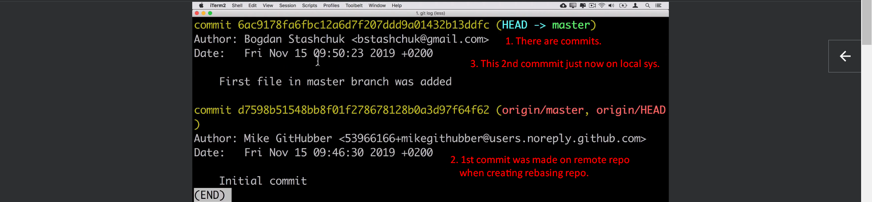
6. 
7. 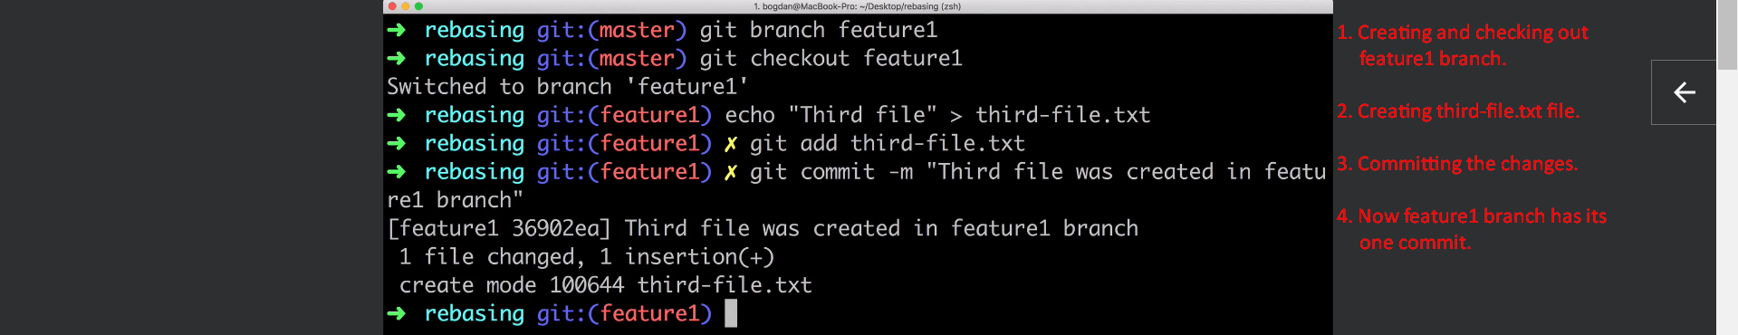
8. 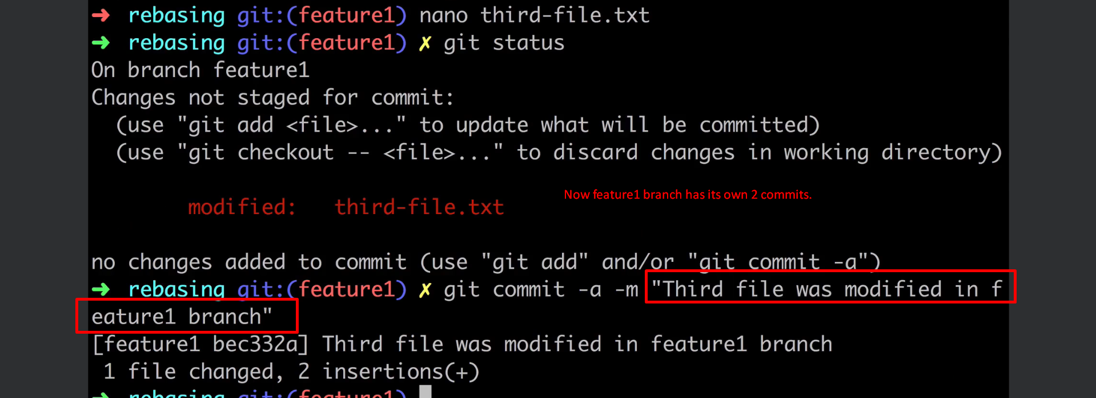
9. 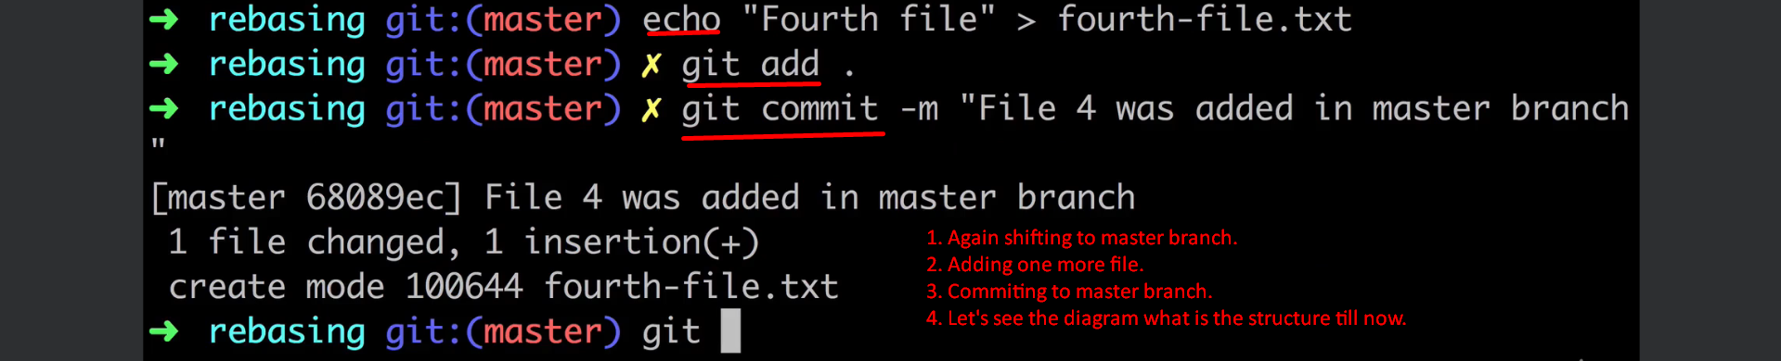
10. 